ADBMS Practical 6

CRUD operations using Neo4j

Movie-Graph

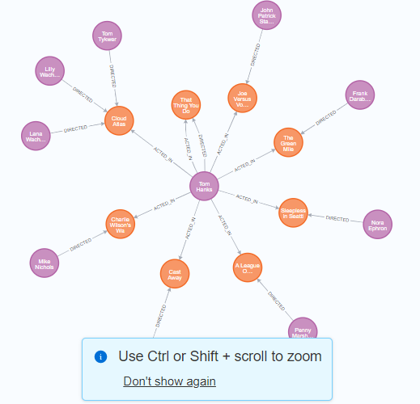

MATCH (people:Person) RETURN people.name LIMIT 10

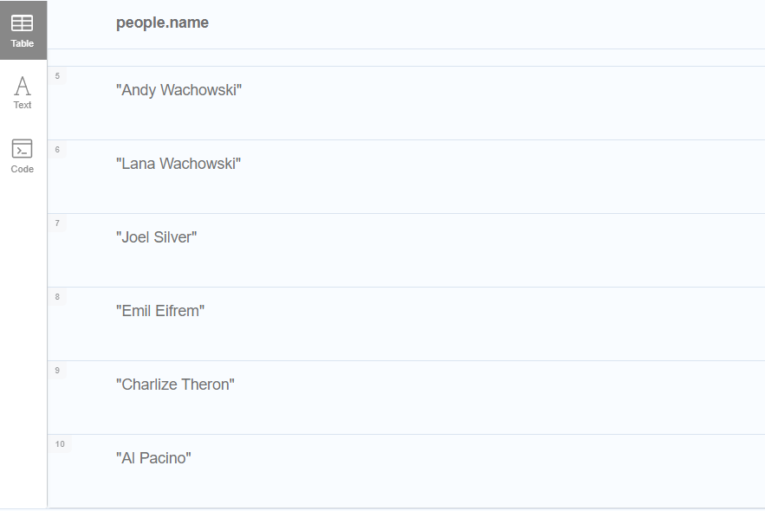

MATCH (nineties:Movie) WHERE nineties.released >= 1990 AND nineties.released < 2000 RETURN nineties.title

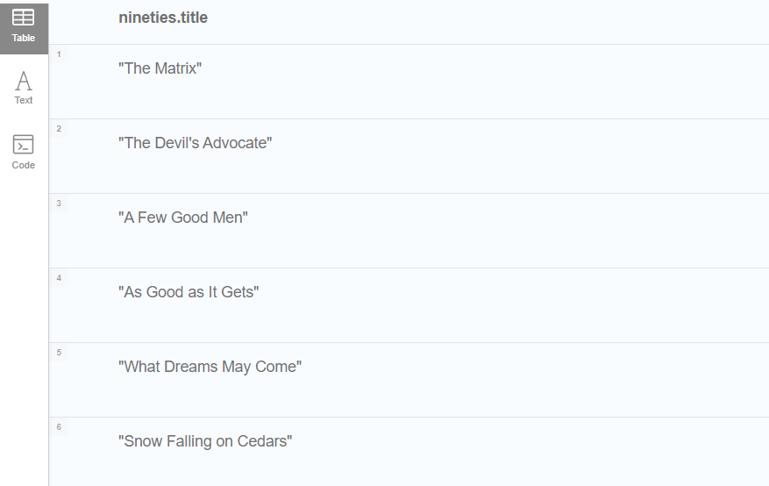

MATCH (people:Person)-[relatedTo]-(:Movie {title: "Cloud Atlas"}) RETURN people.name, Type(relatedTo), relatedTo

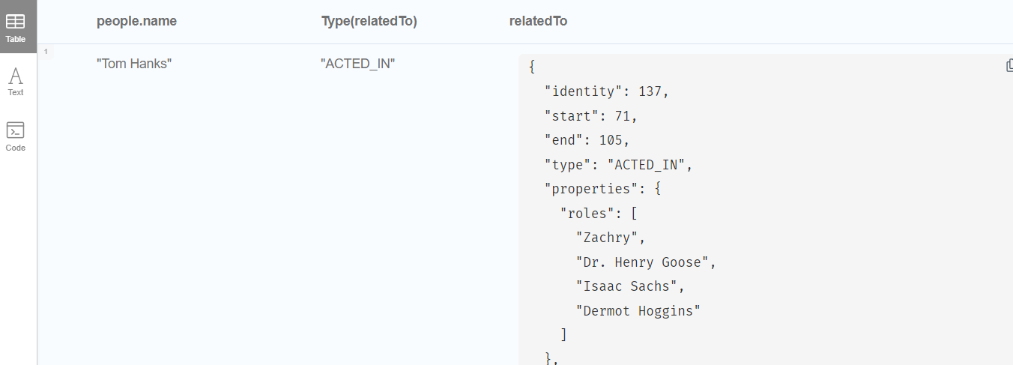

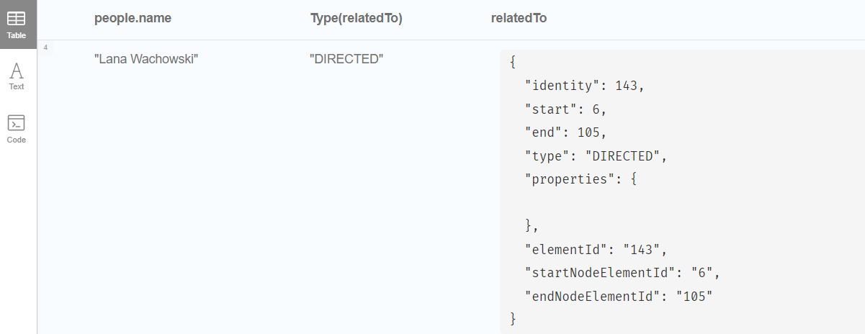

MATCH p=shortestPath(

(bacon:Person {name:"Kevin Bacon"})-[\*]-(meg:Person {name:"Meg Ryan"})

)

RETURN p

